Online Bike Renting System
Process Modeling and Data Modeling /
System Proposal / Analysis Phase
(Homework No.3)

Project team: Team 10
Instructor: Dr. Araz Yusubov

Submitted in partial fulfillment of the requirements of the INFT 2303: Systems Analysis and Design course project

GitHub repository | https://github.com/ADA-SITE-INFT2303-2023-Spring/<name of the repository>
Version date | Version information
<Date> | 21.04.2023
<Date> | 23.04.2023

Team member | Contribution to this homework (NOT the project) | Estimated %
Afsana Mammadova | Introduction / context-level diagram / level 0 diagram / Data modeling | 50
Fredasif Maharramli | Introduction (Bonus 1) / Level 1 diagram / Data modeling | 25
Ahmad Huseynli | Level 0 | 10
Leyla Novruzova | Definition / CRUD Matrix | 15

Table of Contents

Introduction
This is part of the System Proposal for a hypothetical project Online Bike Renting System submitted for partial fulfillment of the requirements of the Systems Analysis and Design course in the School of Information Technologies and Engineering at ADA University, Baku, Azerbaijan.

A complicated software system known as a bike rental system is used to manage data pertaining to bike and customer information, rental history, and invoicing information. Data modeling is therefore crucial to the development of an effective and practical bike rental system. We'll examine the various facets of data modeling for a bike rental system in this homework, such as the identification of entities, processes, data flows, data stores, and so on. In order to develop a precise and thorough model for a bike rental system, we will also cover several data modeling diagrams.

Definitions

Term | Definition
Context diagram  Data flow diagram (DFD)  Level 0 DFD  Level 1 DFD  1:1 relationship  1:N relationship  M:N relationship  CRUD matrix  UML diagram | A top-level data flow diagram that shows visual representation of system’s inputs, outputs, and processes.  A graphical picture of the data flow within the system.  The next level DFD diagram that comes after the context diagram. It defines data stores, external entities, and data flows between all the major processes in the system.  The next level DFD diagram that shows the detailed view of the system. Each process that is mentioned in Level 0 DFD must be decomposed into a more explicit DFD.  A type of relationship where one instance of the parent entity is associated with one instance of the child entity.  A type of relationship where a single instance of a parent entity is associated with many instances of a child entity.  A type of relationship where many instance of a parent entity is related to many instances of a child entity.  Stands for the “create, read, update, delete” matrix. It’s a table that is used to define the functions and actions within the system.  Stands for Unified Modeling Language diagram. It’s a graphical representation of a system’s components and relationships.

Process Modeling

This section will include Context-Level Diagram, Level 0 and Level 1 diagrams.

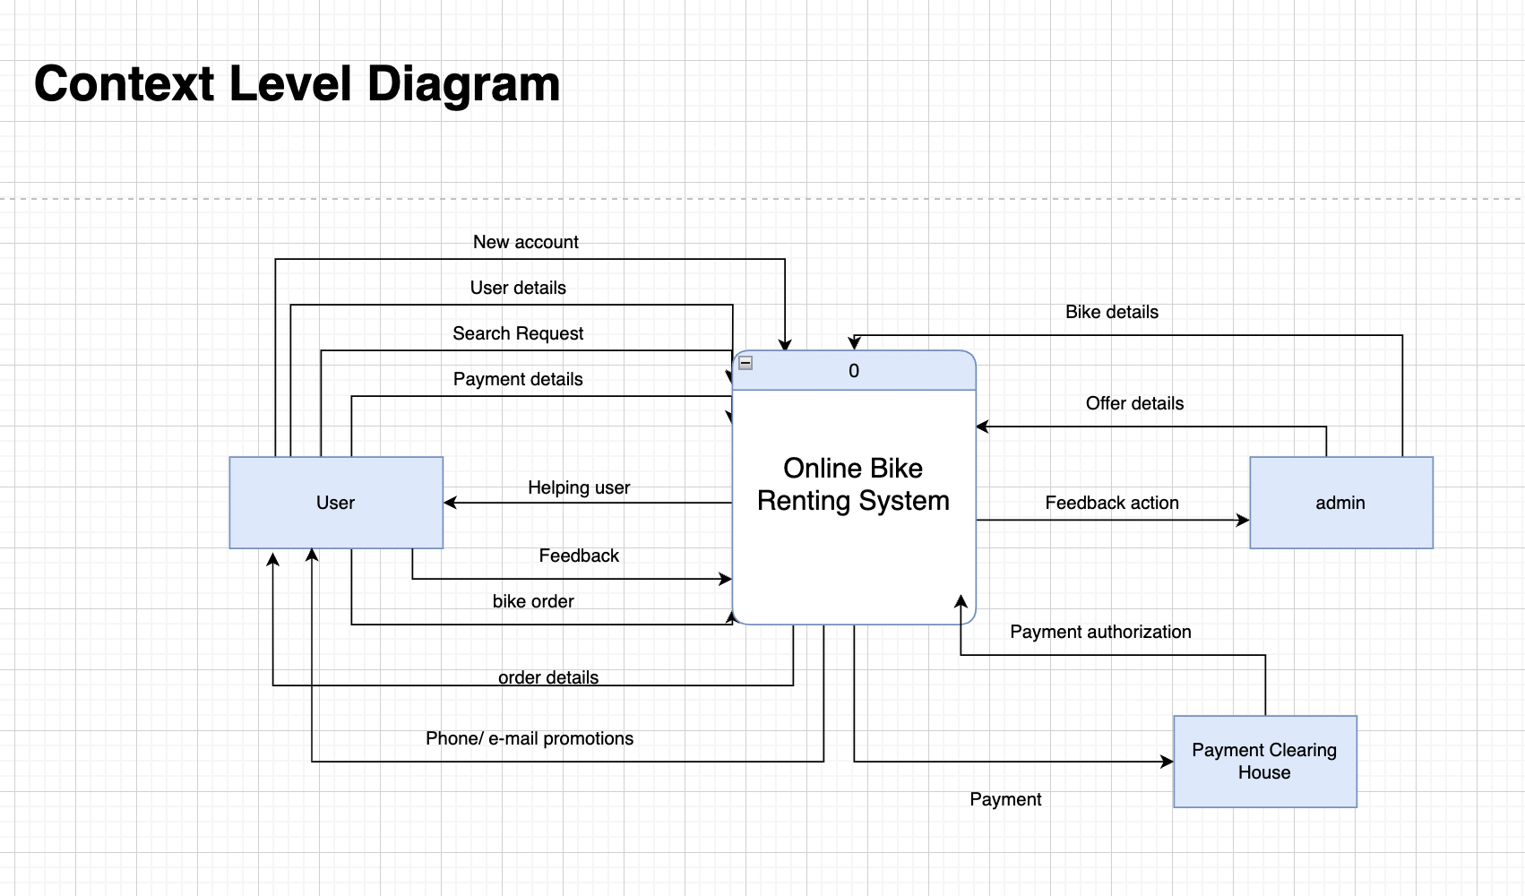

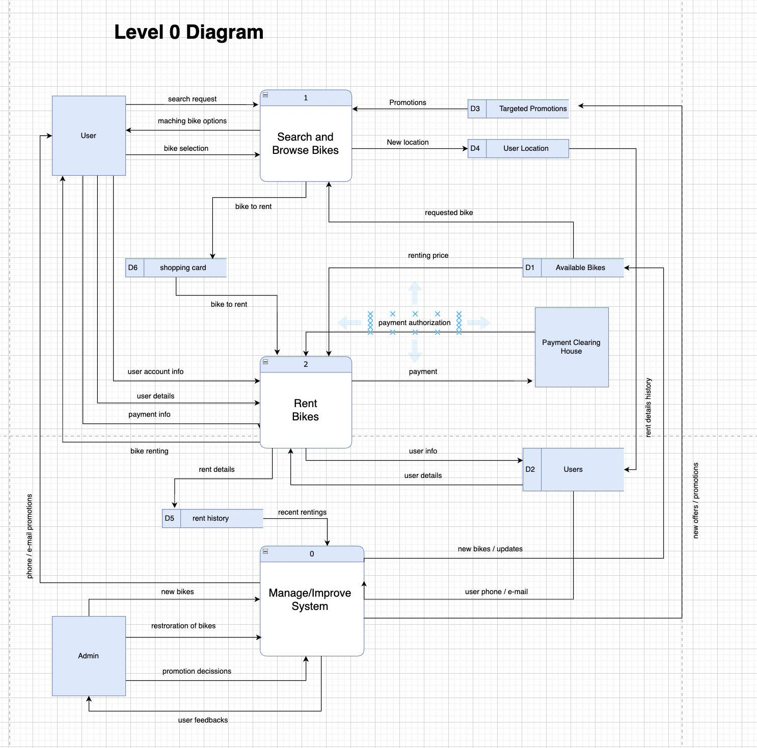

Level 1 Diagrams
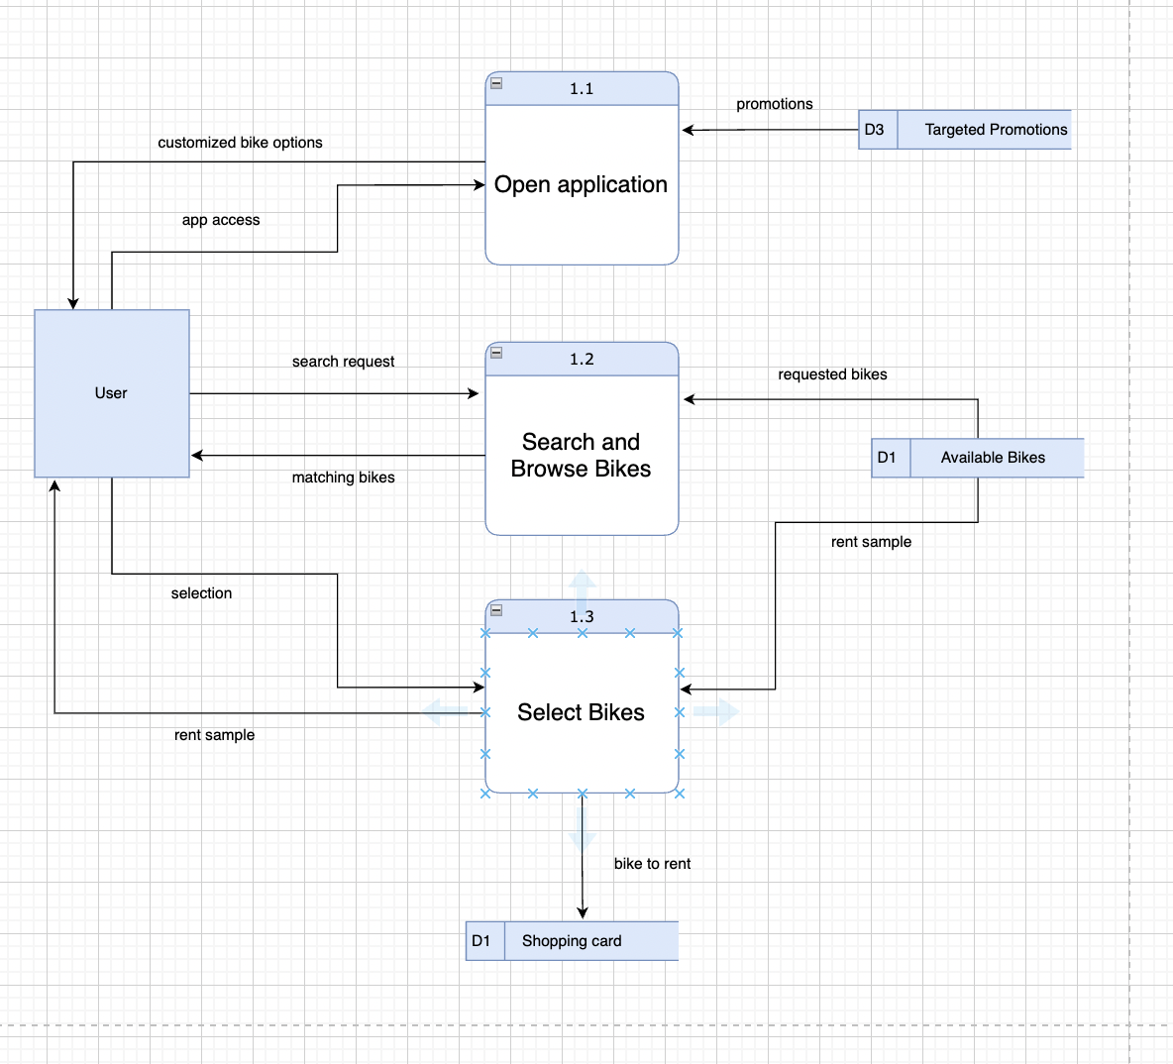
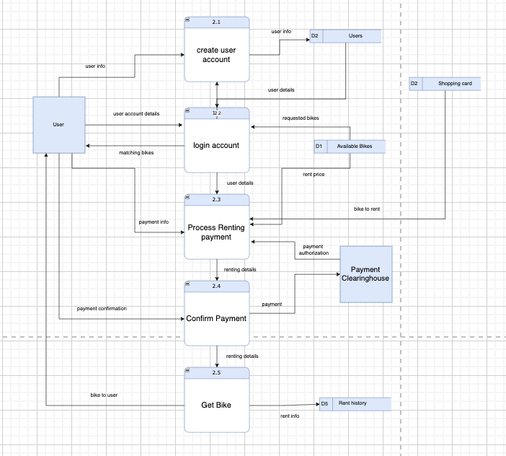

Data Modeling

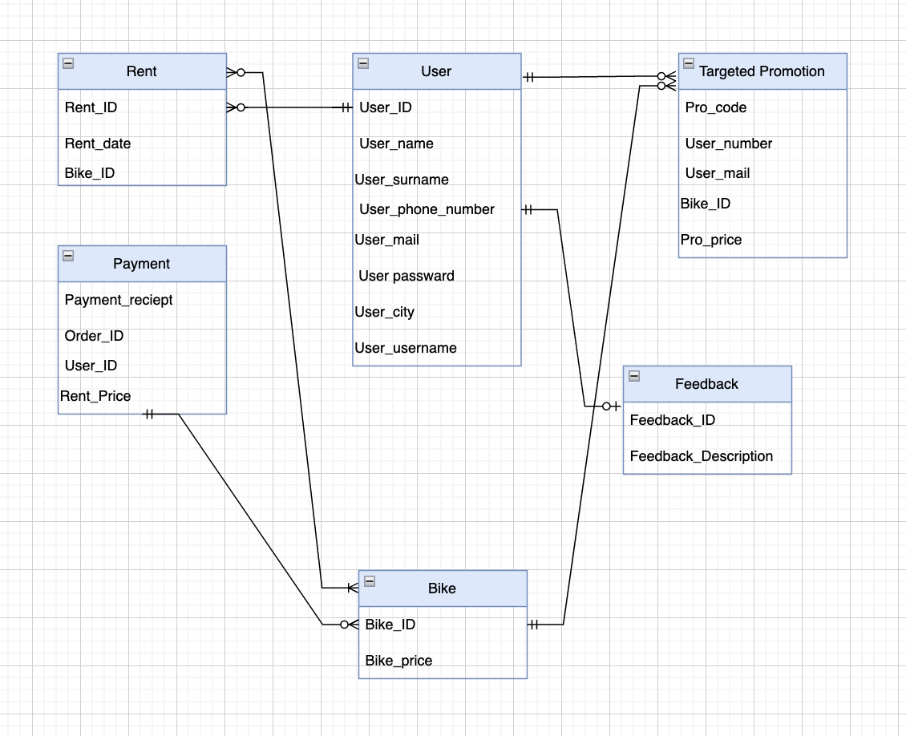

CRUD matrix

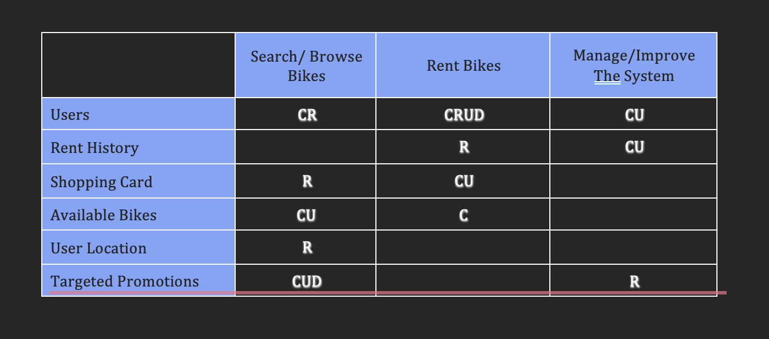References
- Systems Analysis and Design [Dennis], Alan Dennis, Barbara Haley Wixom and Roberta M. Roth, Systems Analysis and Design, 6th Edition / John Wiley & Sons © 2014 (448 pages) ISBN: 978-1118897843

